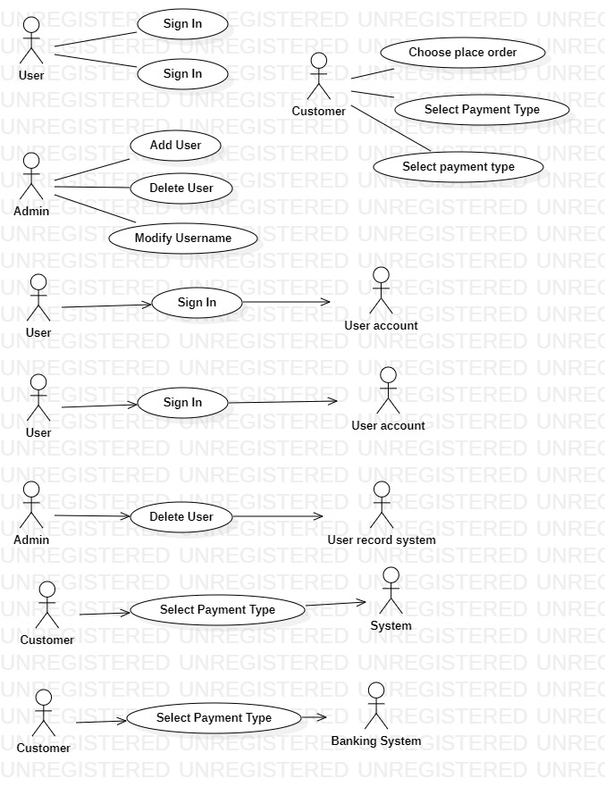
Sign Up
Actors | User, User information
Description | An User send the user information to the user record system with the command that add this user into database
Data | User information
Stimulus | Interface that including username add register button
Response | Message that: register successful or fail (kind of error)
Comments | User must have permission to add user information.

Sign In
Actors | User, User account
Description | An User send the user account to the user record system with the command that check this user from database
Data | User account
Stimulus | Interface that including username add Sign In button
Response | Message that: SignIn successful or fail (kind of error)
Comments | User must have permission to check user account.

Delete User
Actors | Admin, User Record System
Description | An admin send the usename to the user record system with the command that delete this user from database
Data | Username
Stimulus | Interface that including username add delete button
Response | Message that: delete successful or fail (kind of error)
Comments | Admin must have permission to delete user. Some system, they also keep the record but set a flag to show that this user is delete

Choose Goods
Actors | Customer, System
Description | An Customer send the goods to the system with the command that “add to cart”
Data | goods
Stimulus | Interface that including username add “Add To Cart” button
Response | Message that: Added successful or fail (kind of error)
Comments | Customer must have permission to add to cart.

Select Payment Type
Actors | Customer, Banking system
Description | An Customer send the bill to the banking system with the command that “Buy”
Data | Bill
Stimulus | Interface that including username add “Buy” button
Response | Message that: Buy successful or fail (kind of error)
Comments | Customer must have permission to Buy.

